

Secure Dev Labs
Software Agency | Est.2025

Student Information

Student Name | Muhammad Ahmed Raza | Batch | Batch 1
Internship Track | Ethical Hacking | Week / Task | Week 2 / Web App Mapping
Submission Date | 01-05-2026 | Instructor | Muhammad Saad
Tools Used | Burp Suite,  Draw.io, Dvwa | File Name | Ahmed_Raza_Web_App_Mapping_Task2_Week2.pdf

Task Overview
Task Title: Week 2 - Web Application Mapping and Input Discovery.
Task Context: As an intern at Secure Dev Labs, my Week 2 objective is to develop a strong understanding of the “Mapping” stage in a security assessment. Before performing any vulnerability testing, I need to analyze how a web application is structured and how information flows through it. To build these skills, I will create a controlled lab environment to practice monitoring network traffic and discovering the application’s potential attack surface.
- Objective
- Lab Setup: Install and configure a vulnerable web application such as DVWA or OWASP Juice Shop to create a safe and authorized practice environment.
- Traffic Inspection: Use Burp Suite to intercept, examine, and resend HTTP requests and responses for analysis.
- Input Enumeration: Identify all locations where users can provide input to the application, including forms, URL parameters, and request fields.
- Session and Access Control: Learn how web servers use cookies and session management to maintain user identity and enforce access permissions, including the distinction between authentication and authorization.
- Networking Basics: Study the DNS resolution process to understand how human-readable domain names are converted into IP addresses used by machines.

Part A:

DVWA Installation Screenshot
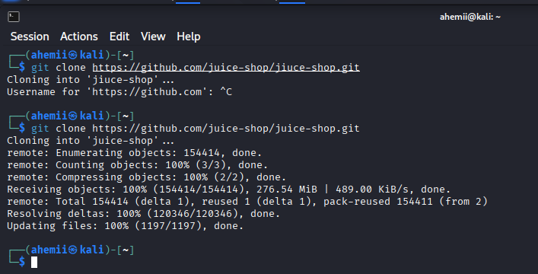

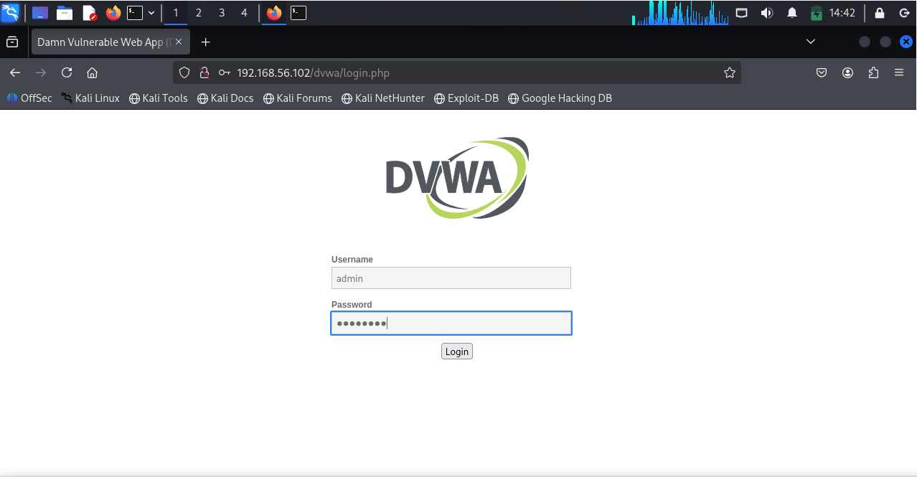

Input Fields Discovery Screenshot
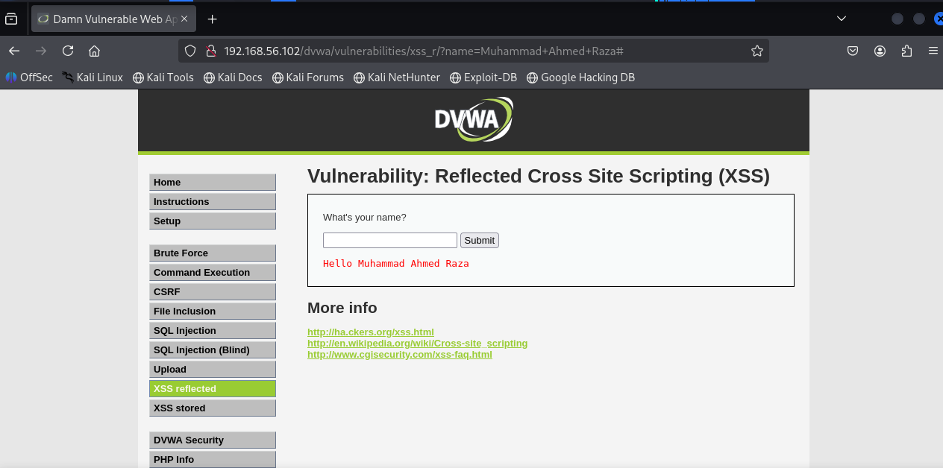

Map all those endpoints that are basically user controlled.

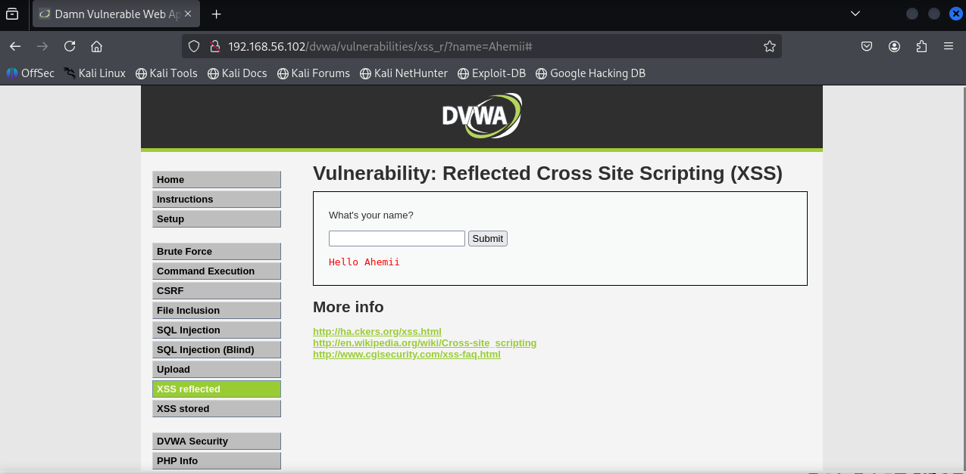

Part B: Burp Suite

Theory:

Burp Suite is a web application security testing tool that comes pre-installed with Kali Linux. It operates as an intercepting proxy positioned between the client (the user’s browser) and the server, allowing analysts to capture, inspect, and modify web traffic.

Difference B\W Burp Suite & Nmap:

Burp Suite | Nmap
It is a tool specifically used for web application security testing. | It is primarily a network discovery and security auditing tool.
It acts as an interceptor between the Client (browser) and the Server. | It scans IP addresses and ports to see what devices and services are active on a network.
It allows you to capture, inspect, and modify HTTP requests and responses | It identifies open ports, operating systems, and network services.
It focuses on finding vulnerabilities in website features like login forms, parameters, and cookies. | It focuses on the infrastructure and the server itself rather than the specific web application pages.

Visualization of Traffic Interception:

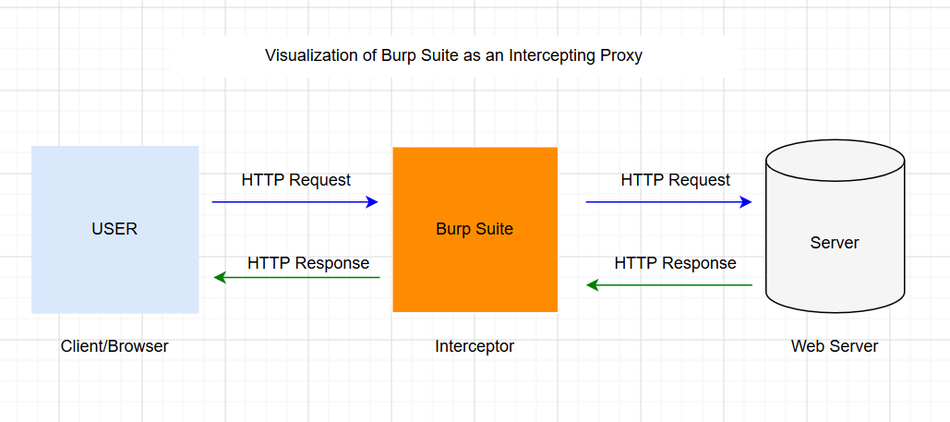

Practical

Capture your first request by using Burp Suite

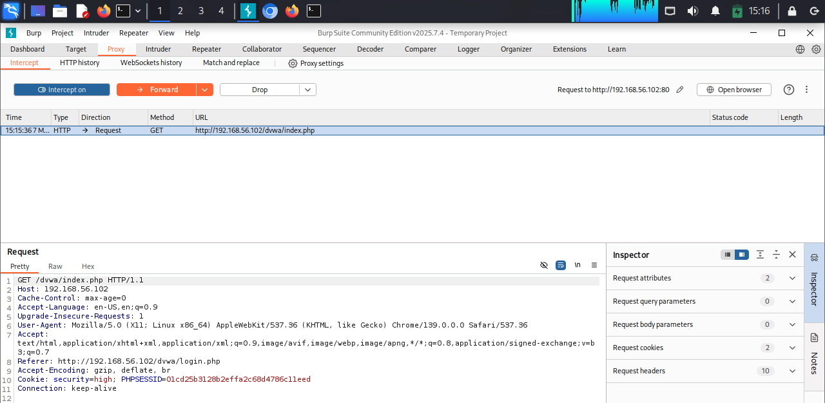

Forward that captured request to the intercept:

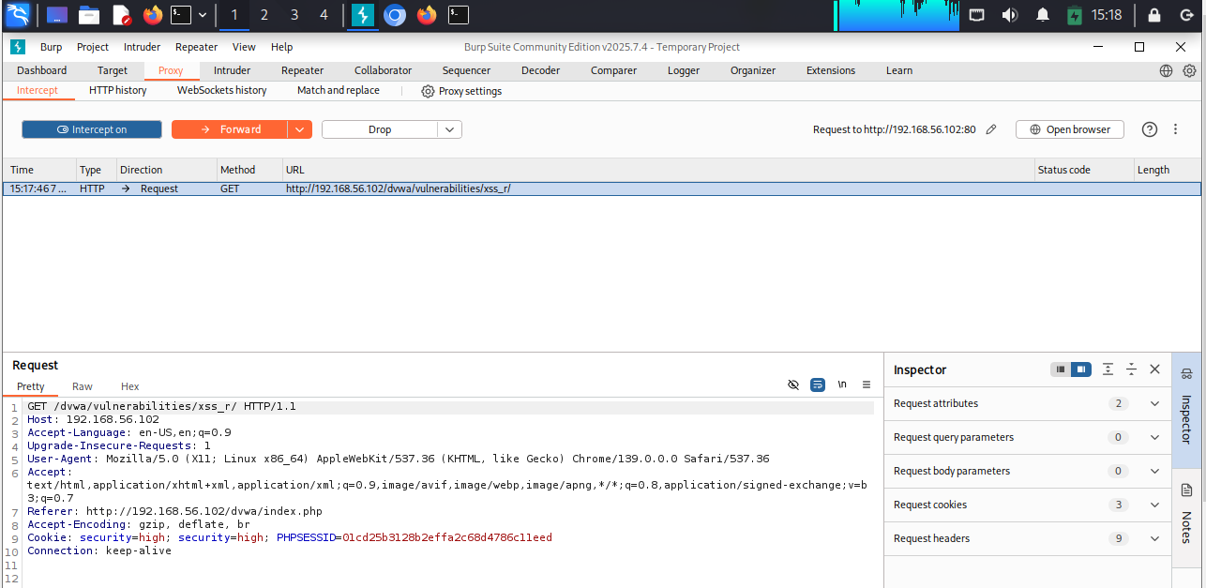

Forward that captured request to the Repeater:

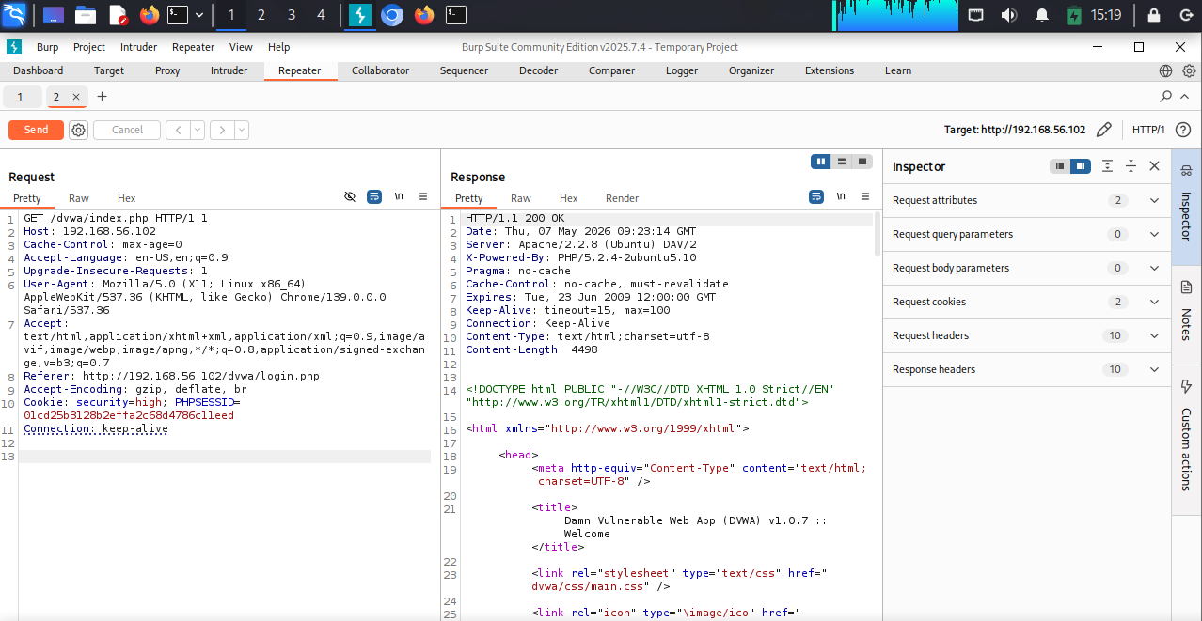

Part C: Request & Response

Request & Response in Web Applications

Request

A request is a message sent from a client, such as a web browser or mobile application, to a web server asking for a resource or service.
Example:
When a user opens a website, the browser sends a request to the server to retrieve the webpage content.

Response
A response is the message returned by the server after processing the client’s request. The response usually contains the requested webpage, data, or an error message.
Example:
The webpage displayed in the browser is the server’s response to the user’s request.

Sender vs. Receiver

Sender (Request)
The client or browser acts as the sender by transmitting a request to the server. This can be compared to asking a question.

Receiver and Feedback (Response)
The server receives the request, processes it, and sends back a response. This is similar to providing an answer.

Example
User requests:
“Please load this webpage.” → This is a Request
Server returns the webpage content → This is a Response

Common HTTP Response Codes
HTTP status codes indicate the result of a client’s request to the server.
- 200 OK → The request was completed successfully.
- 301 Moved Permanently → The requested page has been permanently moved to a new location.
- 400 Bad Request → The request contains invalid syntax or incorrect data.
- 401 Unauthorized → Authentication is required to access the resource.
- 403 Forbidden → Access to the resource is denied.
- 404 Not Found → The requested page or resource could not be found.
- 500 Internal Server Error → The server encountered an unexpected problem while processing the request.

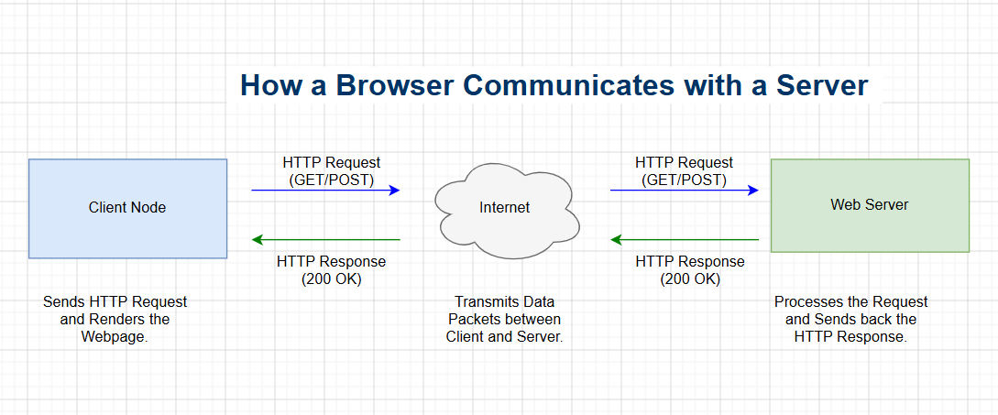
How a Browser Communicates with a Server:

Practical:
Requesting Facebook.com via Browser
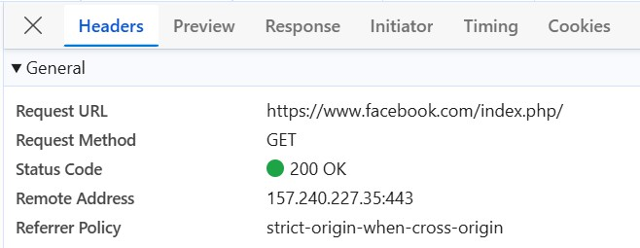

Server Response from Facebook.com

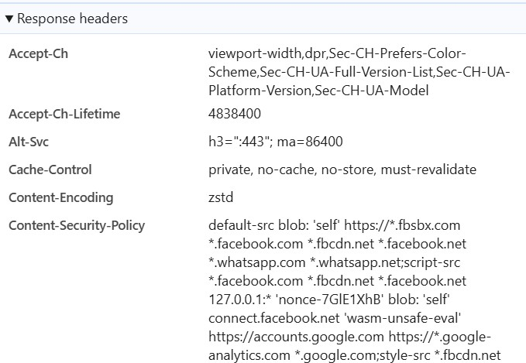

Part D: Cookies and Sessions

Theory:

Cookies: The Client-Side Notebook

A cookie is a small piece of data stored directly on the user's browser. When a server respond to requested it can send a Set-Controlled telling the browser to remember certain information

- Persistence: Can be set to expire when the browser closes (session cookies) or last for months (persistent cookies).
- Storage: Limited to about 4KB.
- Security Risk: Since they live on the user's machine, they can be intercepted (XSS/CSRF) unless protected by flags like Http only and secure.

- Storage: Limited to about 4KB.
- Security Risk: Since they live on the user's machine, they can be intercepted (XSS/CSRF) unless protected by flags like Http only and secure.

Sessions: The Server-Side Filing Cabinet
A session is stored on the web server. It allows the server to keep track of a specific user’s state across multiple
requests

- How it works: The server creates a unique Session ID, stores it in its database (or memory), and sends that ID to the user’s browser as a cookie.

- Security: Much safer for sensitive data (like user roles or credit card info) because the actual data never leaves the server.
- Scaling Challenge: If you have ten servers, they all need access to the same session data, usually requiring a centralized store like Red’s

Why They Are Important in Modern Web Apps

Authentication & Authorization
Without cookies/sessions, you’d have to log in on every request — which is obviously impractical.

User Experience (UX)
Features like “remember me”, shopping carts, dark mode preferences all depend on them.

Security Layer
Sessions help protect sensitive data (instead of exposing everything in cookies).

State Management
Essential for multi-step processes (forms, checkouts, dashboards).

Define Authentication (AUTHN):

Authentication (AuthN) is the process of verifying who a user is. It is the digital equivalent of checking someone’s ID card or passport to ensure they are exactly who they claim to be. It is often confused with Authorization (AuthZ), which determines what a user is allowed to do. To keep them straight: AuthN is about identity; AuthZ is about permissions.

Define Authorization (AUTHZ): Authorization (AuthZ) is the set of permissions that determines which rooms you are allowed to enter once you're inside.

In technical terms, Authorization is the process of verifying what a specific user—already identified—can access or modify.

Write one difference between AUTHN and AUTHZ:
The major difference is that Authentication always happens first to verify identity, while Authorization happens second to verify permissions.

Explain why cookies/sessions are used: HTTP is stateless. Cookies and sessions provide the "memory" needed for the following:

- Persistence: Keeping you logged in so you don't provide credentials on every click.
- State Management: Tracking temporary data, like items in a shopping cart.
- Personalization: Remembering your settings, such as language or "Dark Mode."
- Security: Verifying that requests are coming from a legitimate, recognized user.

Cookie-Based Session Management in Modern Web Architecture
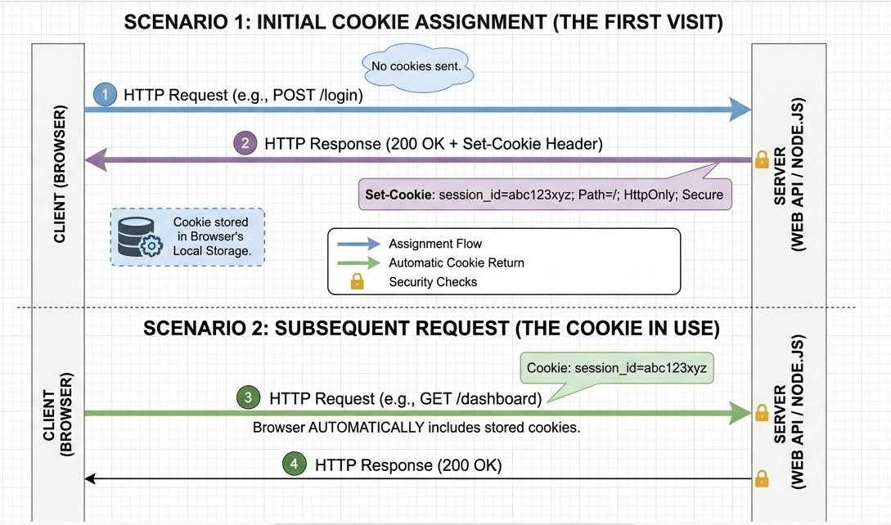

Practical:
Capture the HTTP request during login
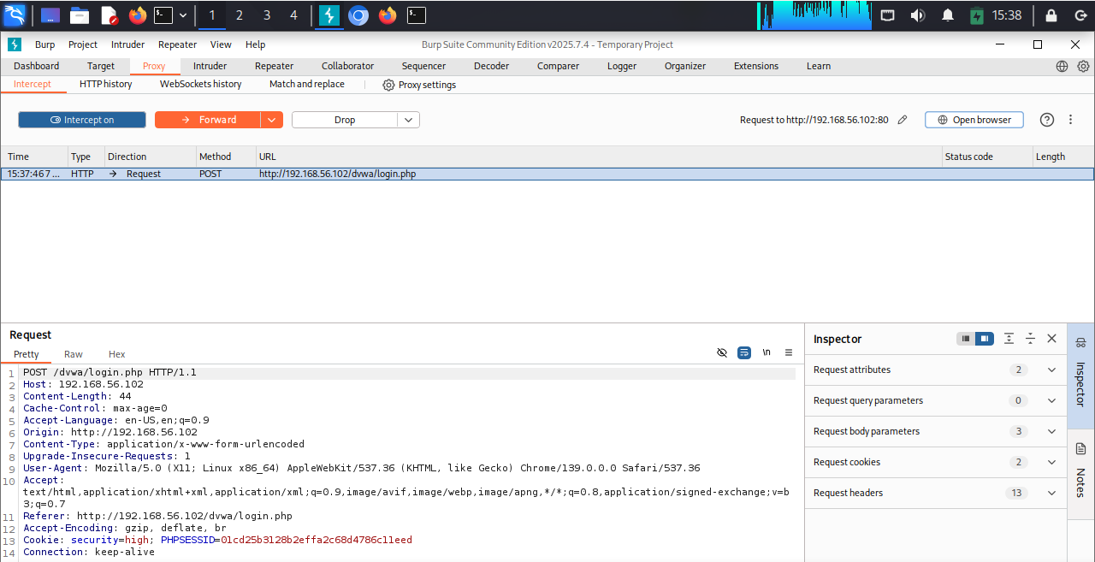

Identify where the credentials appear in the server response

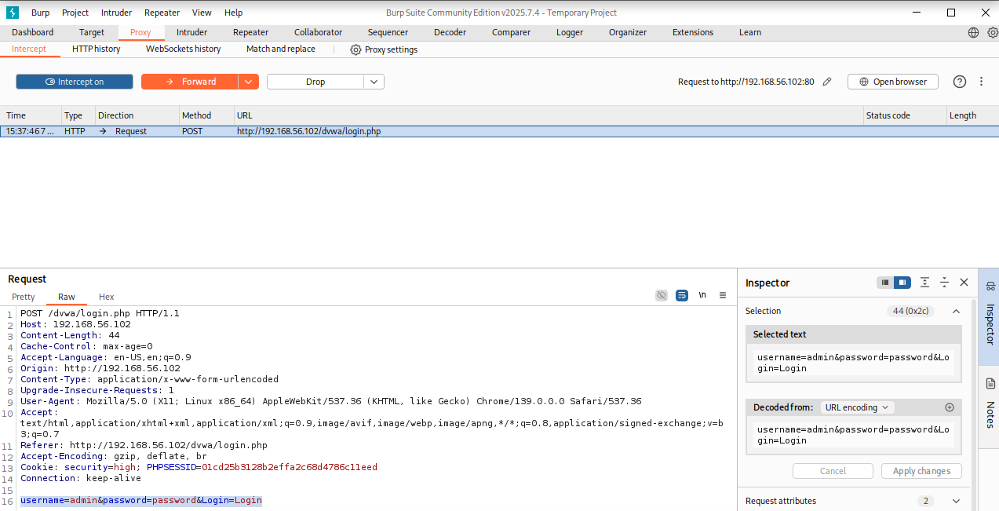

Capture the HTTP request for accessing that directory

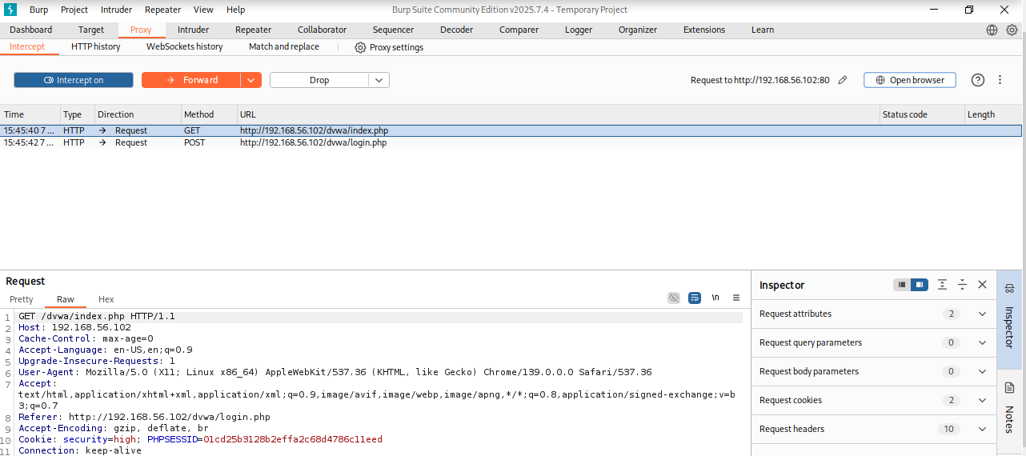

Part E:

Theory:

Domain Name System (DNS)
The Domain Name System (DNS) is an internet service that converts human-readable domain names into machine-readable IP addresses. Since computers communicate using numerical IP addresses, DNS helps users access websites using easy-to-remember names instead of numbers.
Example:
Instead of remembering an IP address like 142.250.190.78, users can simply type a domain name such as google.com.

DNS Request
A DNS request, also known as a DNS query, is the process where a user’s device asks a DNS server to find the IP address associated with a specific domain name.
In simple terms, the device asks:
“What is the IP address for this website name?”
Example:
When a user enters a website URL into a browser, the computer sends a DNS request to locate the correct server for that website.

DNS Response
A DNS response is the reply sent back from the DNS server after receiving the DNS request. It contains the information required for the device to connect to the target web server.
The response typically includes the website’s corresponding IP address.
Example:
If a user searches for example.com, the DNS server may respond with an IP address such as 93.184.216.34, allowing the browser to establish a connection with the website server.

Compare: Domain name (human-readable) and IP address (machine-readable)
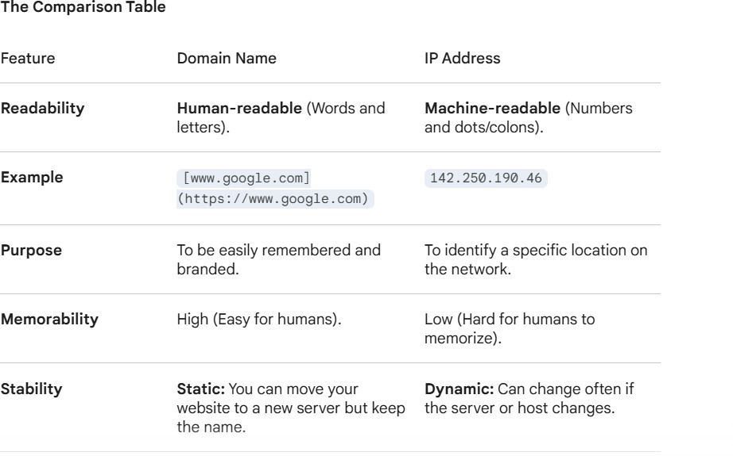

Why is DNS Important for the Internet?
The Domain Name System (DNS) plays a critical role in the functioning of the internet. It acts as the connection between human-readable website names and the numerical IP addresses that computers use to communicate. Without DNS, accessing websites would be far more difficult for everyday users.

Human-Friendly Access
One of the main reasons DNS is important is that it makes the internet easy to use. Humans can easily remember words and brand names, while computers rely on numerical IP addresses.
- Without DNS: Users would need to memorize complex IP addresses such as 157.240.22.35 or 142.250.190.46 to access websites.
- With DNS: Users can simply type familiar domain names like facebook.com or google.com.
DNS improves accessibility and usability, allowing people to browse the internet conveniently without needing technical knowledge of network addresses.

DNS Lookup Process

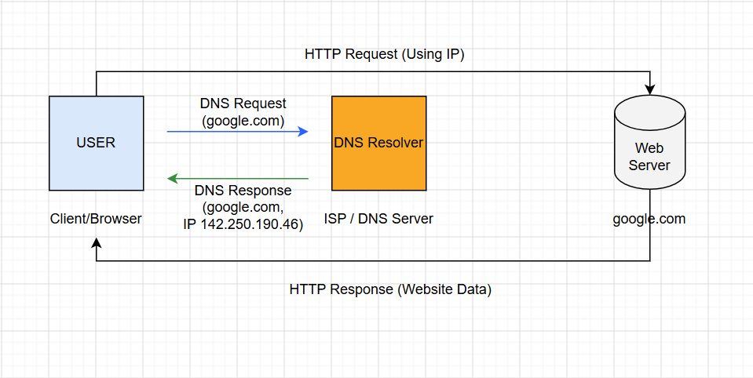

Practical:
Domain Selection: I selected google.com for this practical

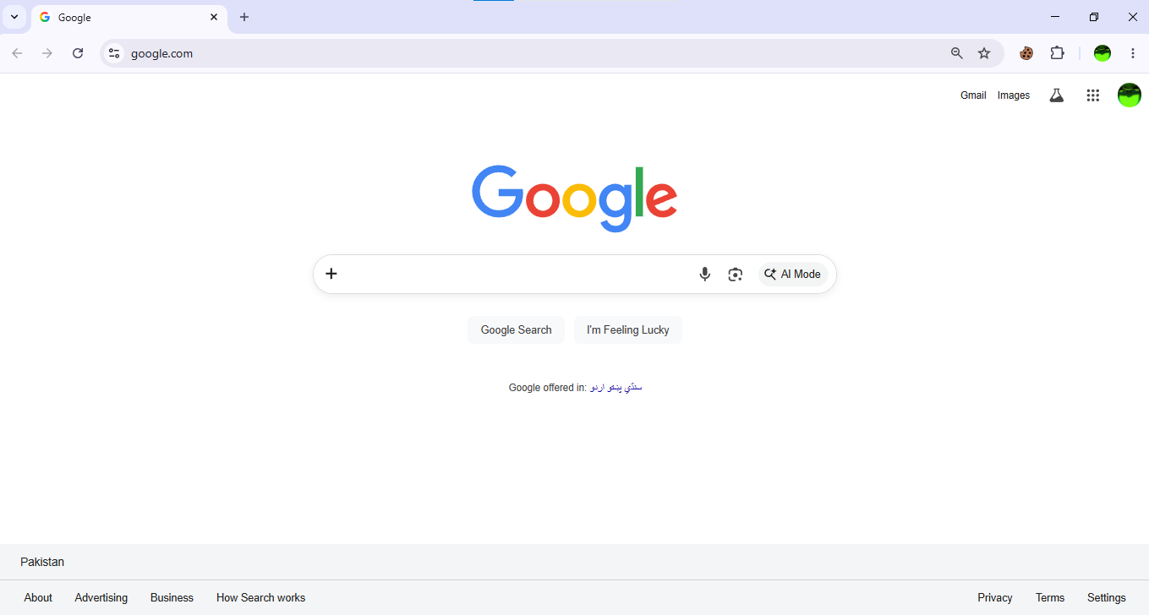

DNS Request/Result:
I used the nslookup command in command prompt to observe the DNS lookup.
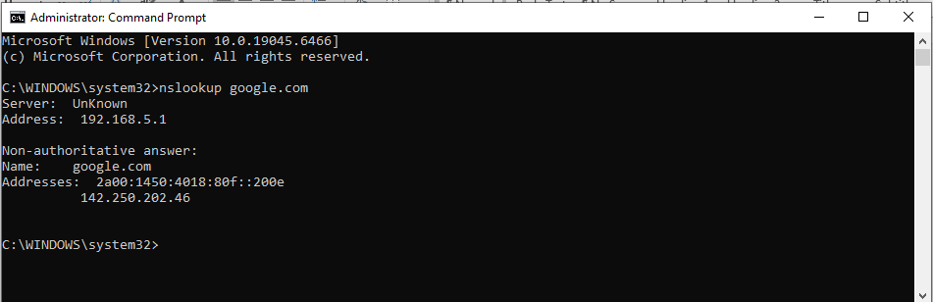

Captured Information

Domain Name: google.com
IPv4 Returned: 142.250.202.46
IPv6 Returned: 2a00:1450:4018:80f::200e
Identification: IP Type: Both ipv4 and ipv6 addresses were identified.
Multiple IPS: Yes, the domain resolves to multiple IP addresses.

